My wife and I currently operate a business that makes and sells wall decorations. Although this business is small and does not require an application to monitor and maintain inventory I will develop an application to check and keep track of inventory as if it did.

The program will meet the problem of providing basic inventory management. For instance a sales person may need to check if an item is available for imitate shipping. Additionally a manufactured may need to generate a list of items that need to be built.

The scope of the project is allow multiple clients across multiple locations to make queries to a central server about inventory levels.

The solution will involve a server that will keep track of inventory levels and will allow checking of that inventory. Also clients will sent messages to the sever asking about various inventory queries. The sever will then return a string containing a response to a client.

The program will have the following functionality.

* Check if an item is available in inventory.
* Check the stock of and item.
* Mark items as sold and change inventory records.
* Display a list of items that need restocking.

The implementation of my solution is as follows

I wrote an IDL describing the interface I needed. The IDL I wrote uses the delegation model because that is the more recent industry standard. This IDL allows for checking if an item is available, checking if an item is in stock, making an item as sold, listing the item with low inventory, and listing all items.

module invintoryApp

{

interface invintory

{

string checkAvailability(in string item);

short checkStock(in string item);

string sellItem(in string item);

string listLowStock();

string listItems();

};

};

Then I wrote the invintoryServer.

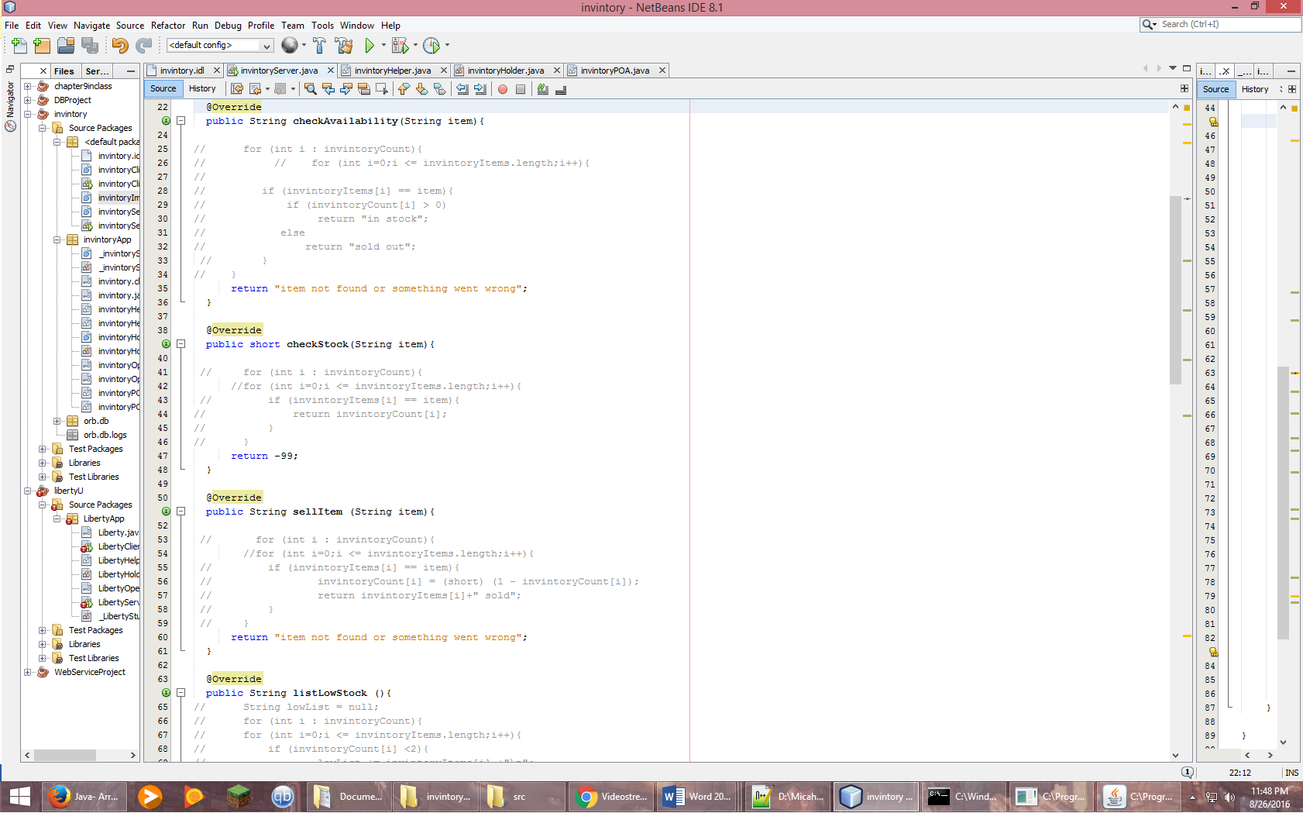

In the end I found that I made an unknown error in the sever logic that produced an exception. Because of this I programmed the server to simply return test strings which it was able to do. Next I wrote the inventoryClinet.

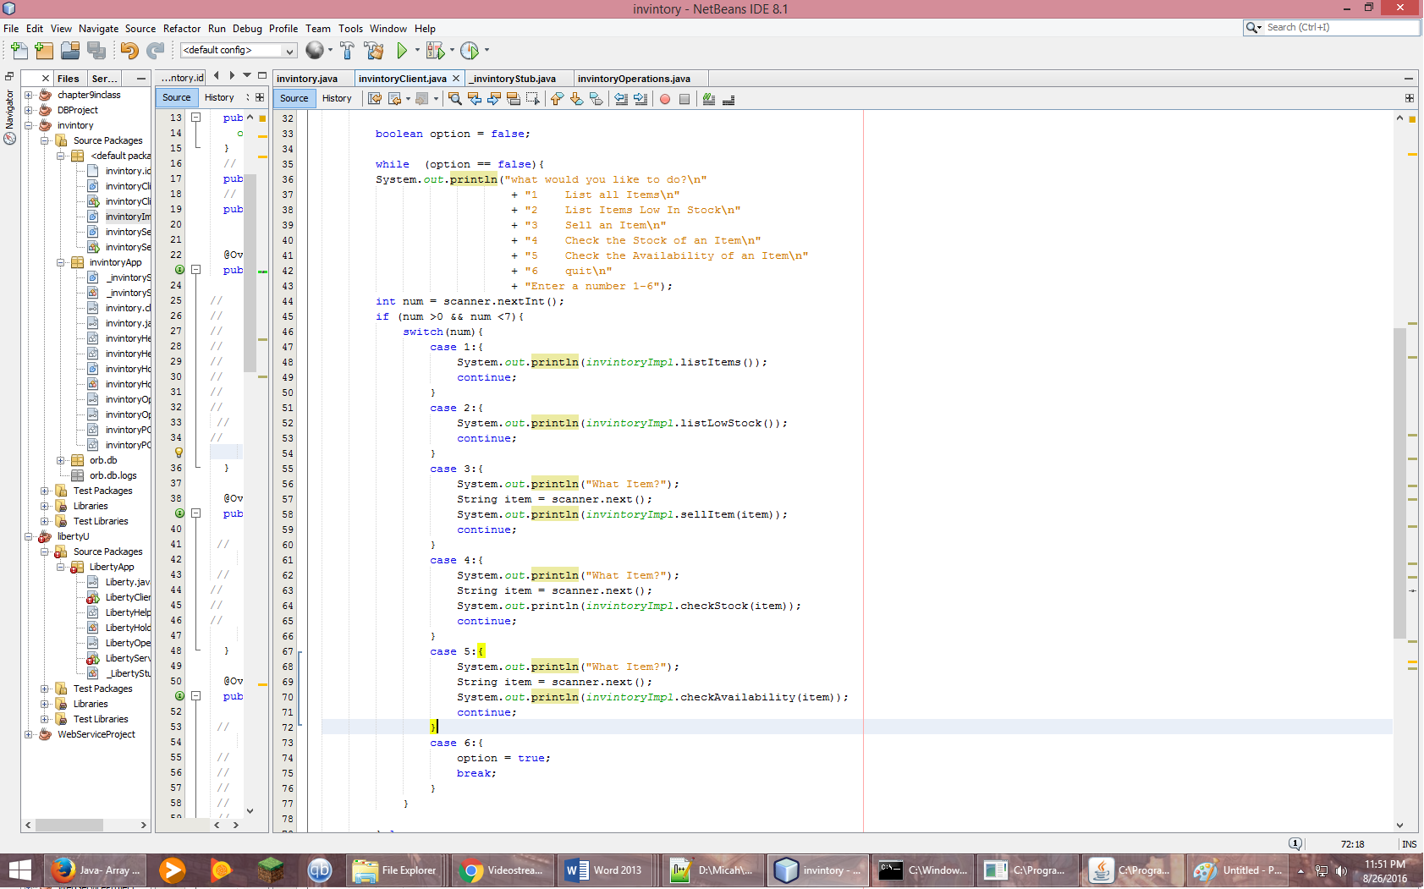

The client follow some simple logic to allow choosing the various options. Then I complied the java programs and started the orbd server and the inventoryServer.

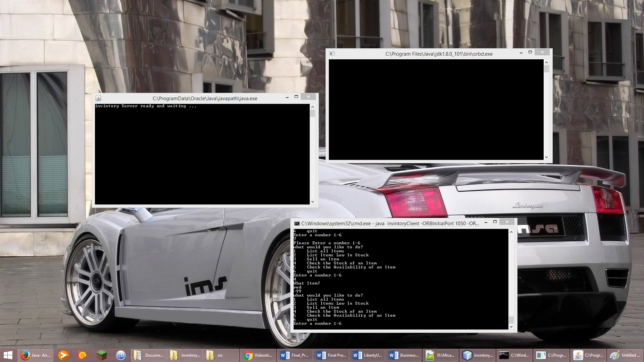

After that I started the client and made some selections.

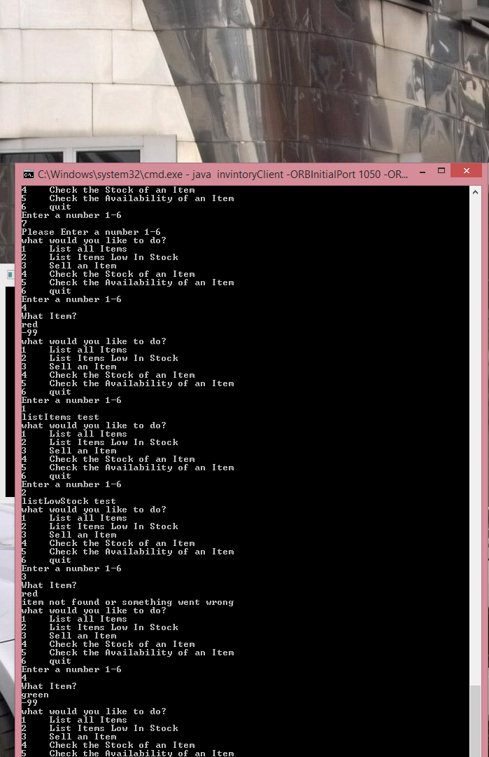

As you can see, although the sever does not respond with proper logic, the client and server are connected. If the problem with the sever had been worked out the sever would be capable of basic inventory management, satisfying the business needs.